Tac Pac
Homework Tips Checklist for Parents

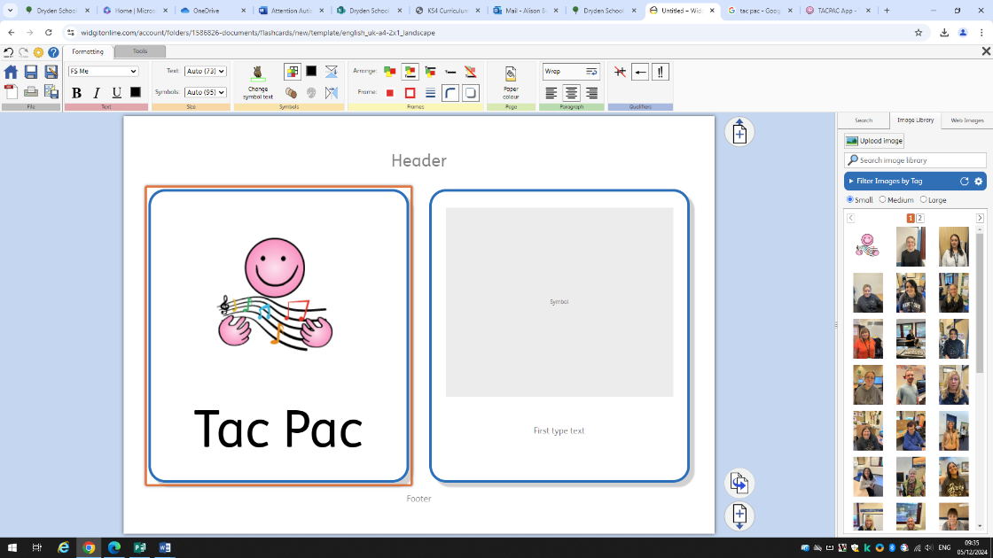
Overview
☐ TACPAC draws together touch and music to create a structured half hour of sensory communication between two people. TACPAC creates sensory alignment and helps people of any age who have sensory impairment, developmental delay, complex learning difficulties, tactile defensiveness, and limited or pre-verbal levels of communication.

Aims and outcomes
☐ TACPAC helps children to interact with those around them as they build a bond of trust with their TACPAC partner.
☐ TACPAC helps children to participate and experience the curriculum through sensory input
☐ When TACPAC is scheduled at the same time each week, the pupils learn to anticipate the session which increases the overall benefit of the communication during ‘TACPAC time’.

Activities/structure
☐ All session is divided into 6 activities, each of which uses an every day object and specially composed music that reflects the texture of that particular object.
☐ Sessions should last around 30mins and there are deep pressure activities contained within the sets and each one ends with relaxation
☐ Staff should work 1:1 with pupils and follow the structure of the session to allow a familiar routine to build

Monitioring
Pupils work 1:1 with a familiar member of staff
Sessions should take place weekly and aim to be at the same time each week to allow a familiar routine to build
Staff should monitor engagement throughout the session e.g video and photos where appropriate
Record of engagement in relation different activities should be recorded to build up a sensory profile
Pupil progress and engagement to be reviewed on a termly basis.
Further information can be found at:
https://tacpac.co.uk/

