Theraputic and Sensory Art
Homework Tips Checklist for Parents

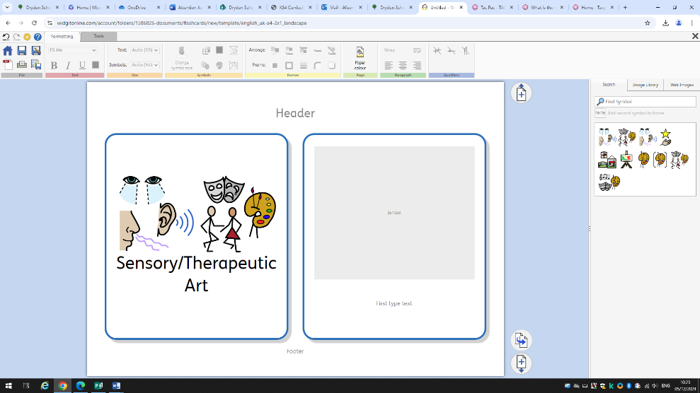
Overview
☐ Therapeutic and Sensory art are sessions which involve creative activities such as drawing, 3D modelling, music or dance.
Therapeutic and Sensory art may help if you find it difficult to put your thoughts and feelings into words. They may also help with addressing painful feelings or experiences.

Aims and outcomes
- Opportunities to communicate thoughts and feelings that you find difficult to put into words
- Help you make sense of things and understand yourself better
- Give you a safe time and place with someone who won't judge you
- Help you find new ways to look at problems or difficult situations
- Help you to talk about complicated feelings or difficult experiences
- Give you a chance to connect with other people

Activities/structure
☐ Part 1: Engaging activities which stimulate the brain e.g. bilateral drawings, follow the leader, mirroring
☐ Part 2: pupil led art making – provide pupils with a range of different art materials including musical instruments, clay, pens pencil and collage. Allow pupils time to create artwork
☐ Part 3: Calming and reflective – talk about the images or art process – how does it make us feel?

Monitioring
Pupils work 1:1 with a familiar member of staff or in a small group
Sessions should take place weekly and aim to be at the same time each week to allow a familiar routine to build
At the ned of 6 weeks review all artwork made, compare and contrast changes
Staff should monitor engagement throughout the session e.g video and photos where appropriate
Record of engagement in relation different activities should be recorded to build up a sensory profile
Pupil progress and engagement to be reviewed on a termly basis.

