Rebound
Homework Tips Checklist for Parents

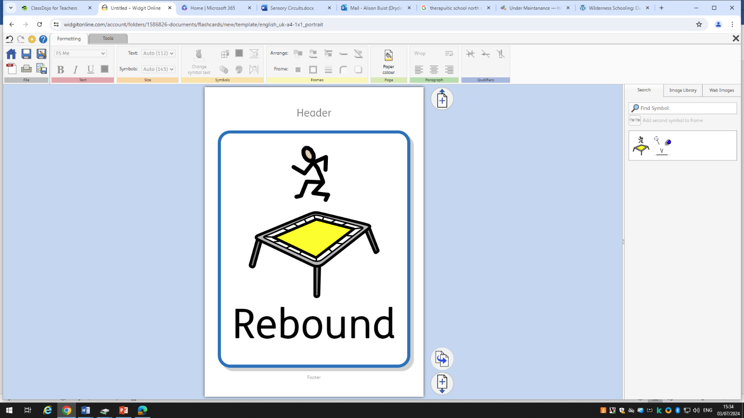
Overview
☐ 'Rebound Therapy' provides pupils the opportunity for movement, therapeutic exercise and recreation on a full size trampoline
☐ REBOUND THERAPY IS used to facilitate and improve movement, balance, increase or decrease in muscle tone, relaxation, sensory integration, fitness and exercise tolerance, and communication skills.

Aims and outcomes
☐ To provide opportunities for pupils to work towards and achieve their EHCP and PfA outcomes alongside recommendations from the physiotherapy teams
☐ Rebound therapy can also be used to as focus for:
- NUMERACY
- PATIENCE
- COMMUNICATION
- CO-ORDINATION
- INDEPENDENCE
- SELF-CONFIDENCE
- REACTION SPEED
- SELF IMAGE
- EYE CONTACT

Activities/structure
☐ Warm up/engagement activities:
- Understanding turn taking and waiting turns to go on trampoline
- Preparing for accessing the trampoline – opportunities to be independent and organized e.g being dressed appropriately, taking shoes off
- Listening to instructions
- Communicating to staff preferences
- Numeracy activities – relating to the curriculum e.g. counting numbers relating to the number of bounces and then stopping

☐ Physical/Alerting Activities:
- Bouncing to favourite song with staff
- Bouncing at different speeds
- Independent bouncing
- Creating different shapes when bouncing – copying
- Listening and keeping safe
- Eye contact with staff whilst bouncing – following their lead

☐ Calming Activities:
- Calming music
- Lying down with pressure hug whilst another member of staff creates small bouncing movements
- Relationship building (Thrive) feeling safe
- Cool down, relaxation of muscles and sensory system

Monitioring
Pupils work 1:1 or 2:1 with staff. Staff monitor pupils interaction and communication skills. Staff record weekly sessions via video or photographs to support progress.
Staff differentiate stages to ensure pupils are challenged and engaged at all stages.
Pupils should ideally spend 5mins at each stage, but some pupils may require more time in the calming stage to ensure they are regulated before leaving the trampoline.
Whilst waiting for turn taking, opportunities for engagement and preparation should be encouraged as part of the routine. Once the pupil’s session has finished on the trampoline, further calming activities should be provided e.g drink snack and calming choice activity
Use a personalised visual strip/task strip to help pupils go through the activities in a structured way.
Pupil progress and engagement to be reviewed on a termly basis.

