SEND Swimming sessions

Friday, 19/01/2024 | GO Gateshead (Sports & Leisure)

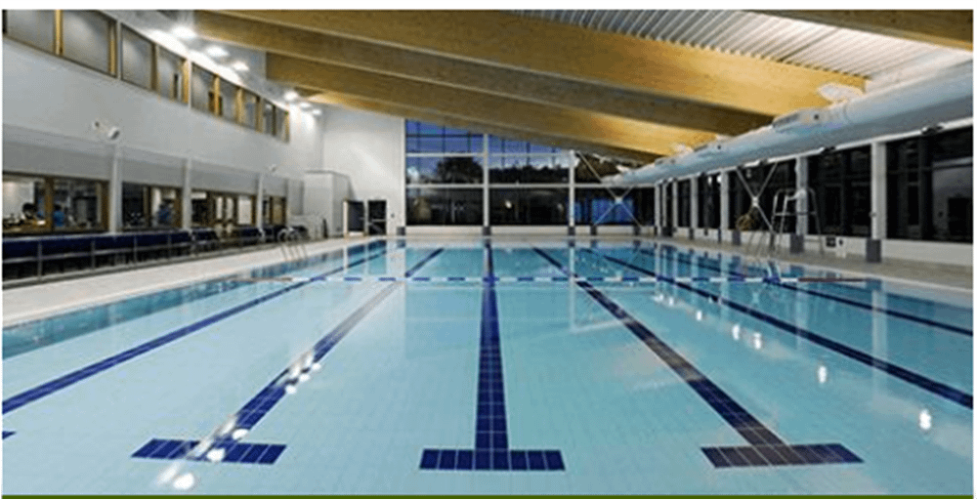

**These sessions are intended to be a quieter session aimed at families who have children with special educational needs and disabilities (SEND). Although SEND swimmers are welcome at all swimming sessions, this dedicated session will give an opportunity for the whole family to swim in a more relaxed environment.**  
  
**Proof of disability status is not required to access these sessions.**

**SEND family swimming sessions take place across our three swimming pools on a weekly basis**

* **Dunston Leisure Centre  - Saturday 6.00p.m  -7.00pm.**
* **Heworth Leisure Centre  - Sunday 3.00p.m  -4.00p.m**
* **Blaydon leisure Centre  - Sunday 8.00a.m  -9.00a.m (main pool only)**

[**You can use this link for contact details of the swimming pools**](https://www.gogateshead.com/article/5864/Contact-us)