Sensory circuits
Homework Tips Checklist for Parents

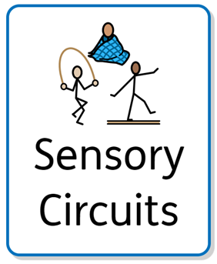
Overview
☐ A sensory circuit is a form of sensory integration intervention.
☐ It involves a sequence of physical activities that are designed to alert, organise and calm the child over 15-20mins.
☐ The sensory circuit aims to facilitate sensory processing to help children regulate and organise their senses in order to achieve the ‘just right’ or optimum level of alertness required for effective learning.
☐ The circuit should be an active, physical and fun activity that children enjoy doing.
☐ Sensory circuits are a great way to both energise and settle children so they can focus and engage better in the classroom.

Aims and outcomes
☐ To provide a way for pupils to regularly receive a controlled sensory input to support attention and engagement.
☐ Alerting:
- The aim is to provide vestibular stimulation (providing the brain with sensory information every time the position of the head moves in relation to gravity) and proprioceptive (awareness of body in space) stimulation within a controlled environment
☐ Organising:
- To promote multi-sensory processing and balance, as the pupil needs to organise their body, plan their approach and do more than one thing at a time in a set sequential order.
☐ Calming:
- To provide input to support the children to complete the circuit feeling calm and focussed

Activities/structure
☐ Alerting Activities:
- Jumping on a trampette
- Sitting and bouncing on a gym ball
- Star jumps
- Marching
- Step-ups
- Skipping
- Lying over a gym ball on their tummy, roll forwards and weight bear through the arms

☐ Orangising Activities:
- Catching a ball or beanbag
- Throwing a ball or beanbag to a target
- Balancing on wobble boards or walking along a gym bench
- Crawling through a tunnel
- Jumping through hoops (3-5 hoops)
- Log rolling - with hands clasped and arms stretched out above the head
- Crawling through a tunnel
- Animal walks eg crab walk, bunny hops

☐ Calming Activities:
- Have an adult apply deep pressure through child’s shoulders using the palms of their hands (keeping fingers together). Maintain the pressure for up to 10 seconds, repeat 3 to 5 times
- Chair or wall push-ups
- Child lies on their tummy over a gym ball and rolls over gently, backwards and forwards
- Child lies down on their tummy and an adult rolls a gym ball on their back using firm, consistent pressure
- For older children, stretch a theraband or resistance bands in front of their body or above their head. Repeat 5-10 times

Monitioring
Pupils must be supervised when completing the circuit. It is important to consider that each pupils’ tolerance and sensory needs are different so they should be able to work at their own pace.
Ideally, pupils should spend up to five minutes per station, on different activities. Some pupils may need more time in the alerting or calming section to help them to be more organised and prepared for the day’s learning or activities.
Activities should be changed and adapted to meet individual needs
Use a personalised visual strip/task strip to help pupils go through the activities in a structured way.

