**Whole School Data Analysis 2022 – 2023**

The following data was generated through EarWig, our assessment software package. All teachers are required to enter their teacher assessment levels for every child, every term. We have 3 different assessment pathways

**The Core Framework**

This framework is a bespoke bank of over a thousand “ I can” statements. Currently this assessment is used with KS3 and KS4.  This data is ongoing teacher assessment and therefore subjective and formative.

**The Pre Formal Curriculum**

This framework is another set of bespoke “ I can” statements. This assessment is used with our PMLD pupils and is specifically designed to show small steps of progress in physical development, cognition and communication.  This data is ongoing teacher assessment and therefore subjective and formative.

**Post 16 Framework**

This framework contains the ASDAN units which all pupils will be working towards. We have 2 main routes through ASDAN, Employability and Pupil Progress.

We also use Earwig to assess our **Functional Reading Programme**. This is delivered across school, in every class other than the PMLD pupils. We have a bank of around 36 words, specific to the needs of our children, which are split into 6 topics, with one topic taught every half term. This is repeated every year, as repetition aids retention. The retention of this is measured by a flash car test at the start of the topic and then the words are taught throughout the half term. This data is objective as it is tested and is summative.

**Functional Reading**

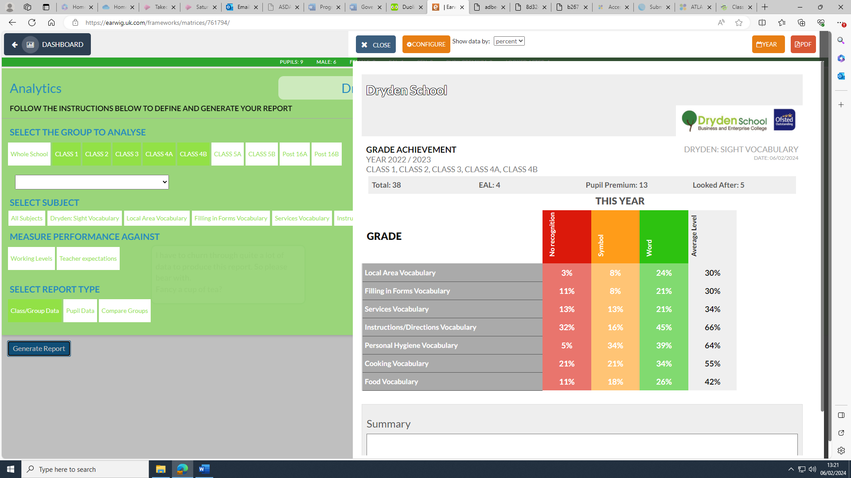

The above grid shows very pleasing progress in the Functional Reading Programme.

In the academic year 22-23 we see that in every set of vocabulary there is a higher % of pupils who can sight read the full word than those who can either read it using symbol support or have no recognition at all. This was not the case in 20-21 where we only see this trend in 3 sets of words. This shows how teaching the same set up words year on year leads to retention of the knowledge and is building up a bank of words for many pupils. In the year 23 – 24 we would like to see the % of pupils with no recognition decrease further.

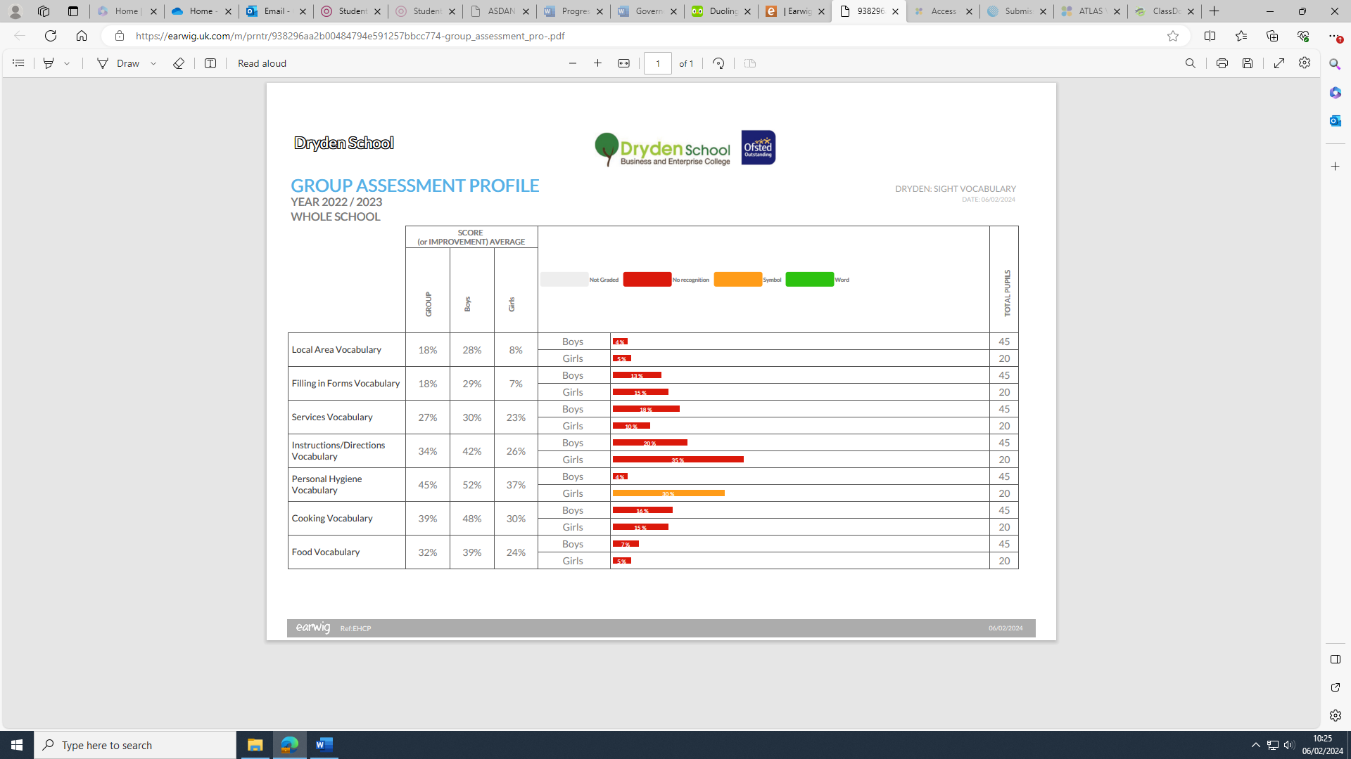

The above grid shows us that boys are outperforming girls in the Functional Reading Programme. The reason for this is unknown. The discrepancy could be due to the average level of need of the girls being slightly lower and things haven’t averaged out with a set of only 20 girls. The data is backed up with the overall literacy scores for boys being higher in the first sets of data analysed. Further work could be done in classes to establish if there is something in the bank of words or the way in which the programme is delivered which lends itself more to the boys.

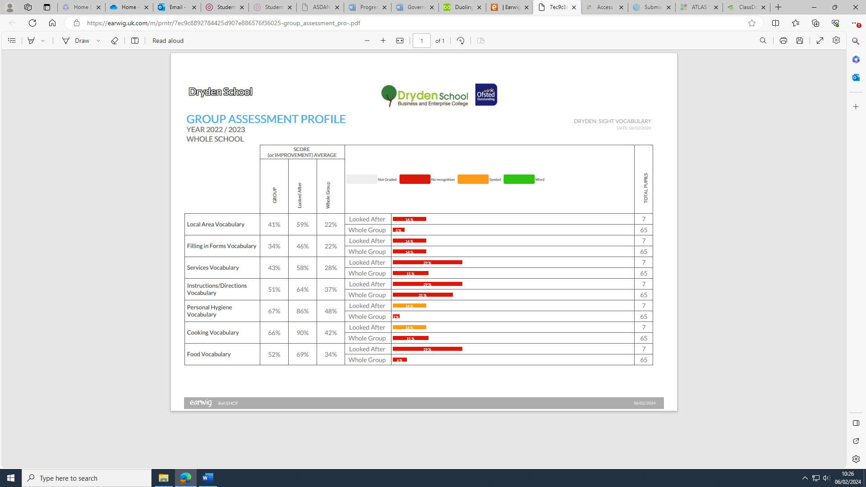

The above grid shows that the LAC pupils are outperforming the other pupils in all of the 6 sets of vocabulary. The LAC pupils are all male so reasons for this could be linked to the previous analysis.

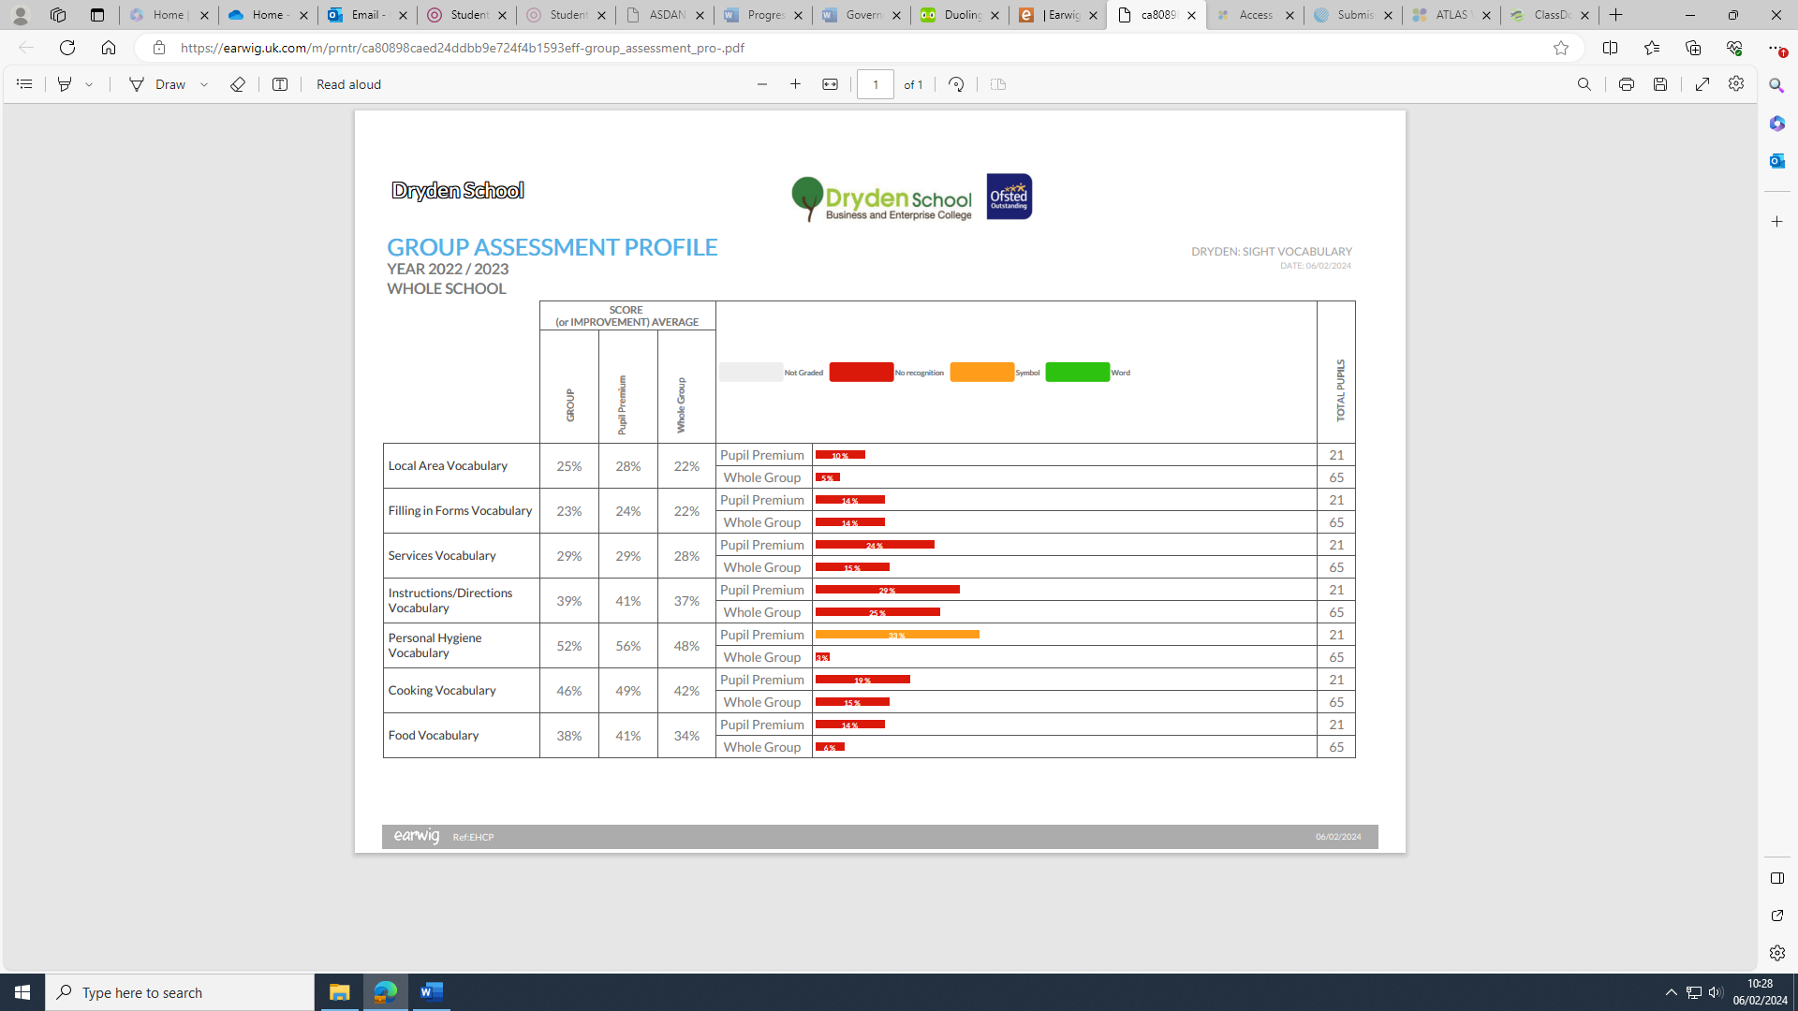

The above chart shows there is no statistically significant variation between those on pupil premium and the whole group.

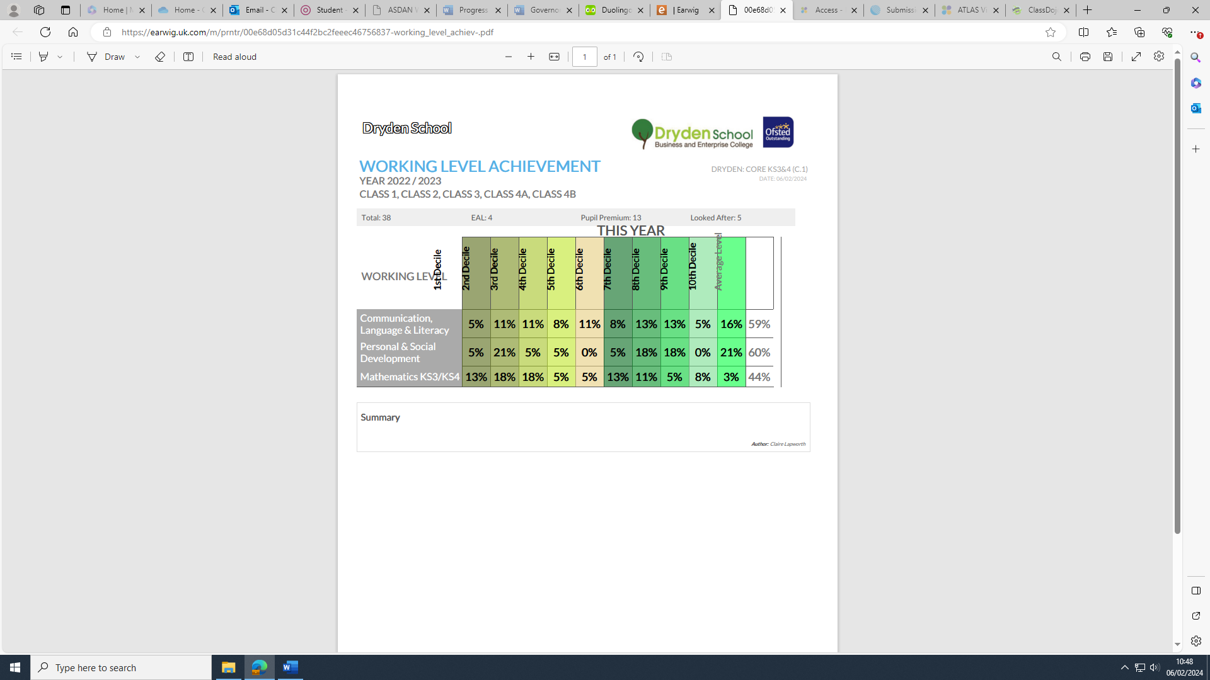

The above table shows the spread of working levels across all pupils assessed with the Core Framework. It shows us that pupils perform best in PSD, followed by Literacy and then Mathematical Thinking. As a school we would expect this, as we focus heavily on independence and other aspects of PSD. We were already aware that Maths was potentially an area for improvement have just recently introduced a new Maths curriculum and an updated framework. There has already been staff training on this curriculum and on teaching techniques. This data needs to be closely monitored next year to ensure the maths curriculum develops in the way we would like.

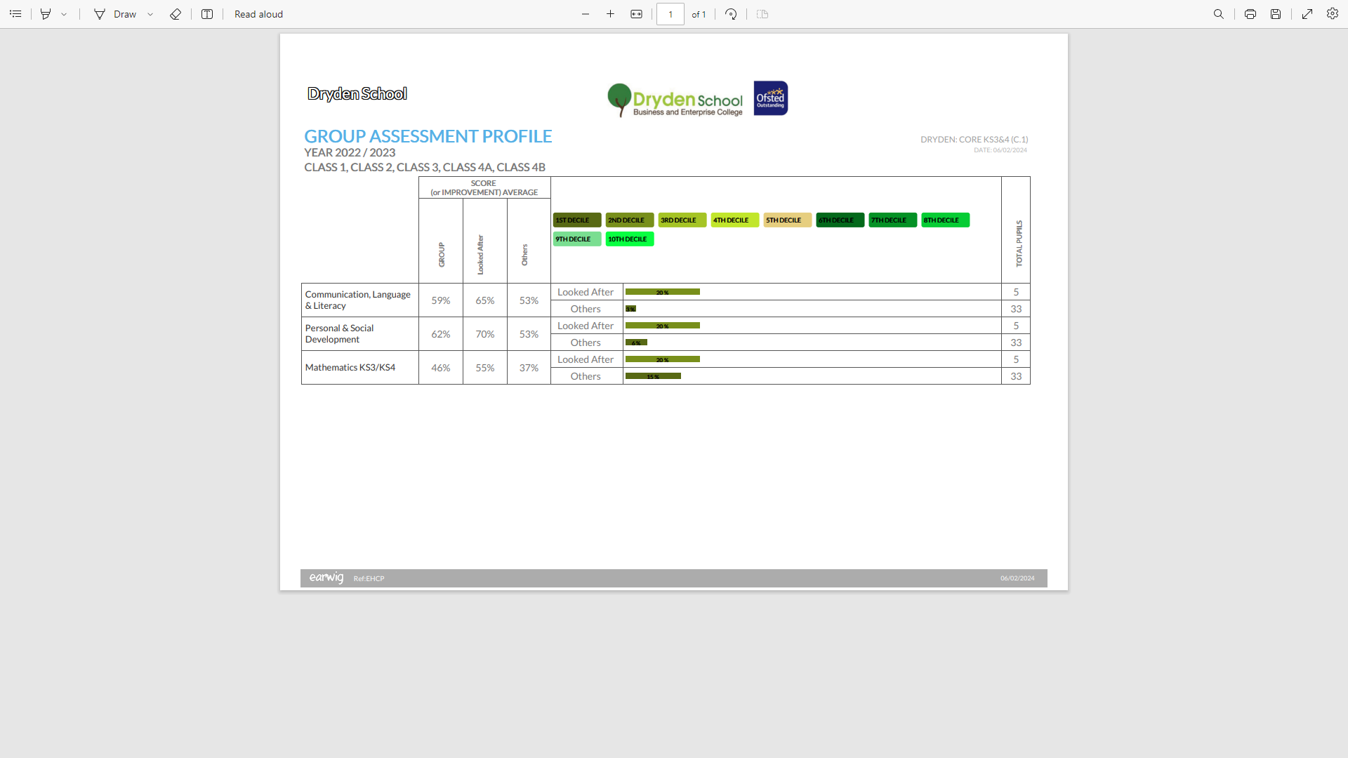

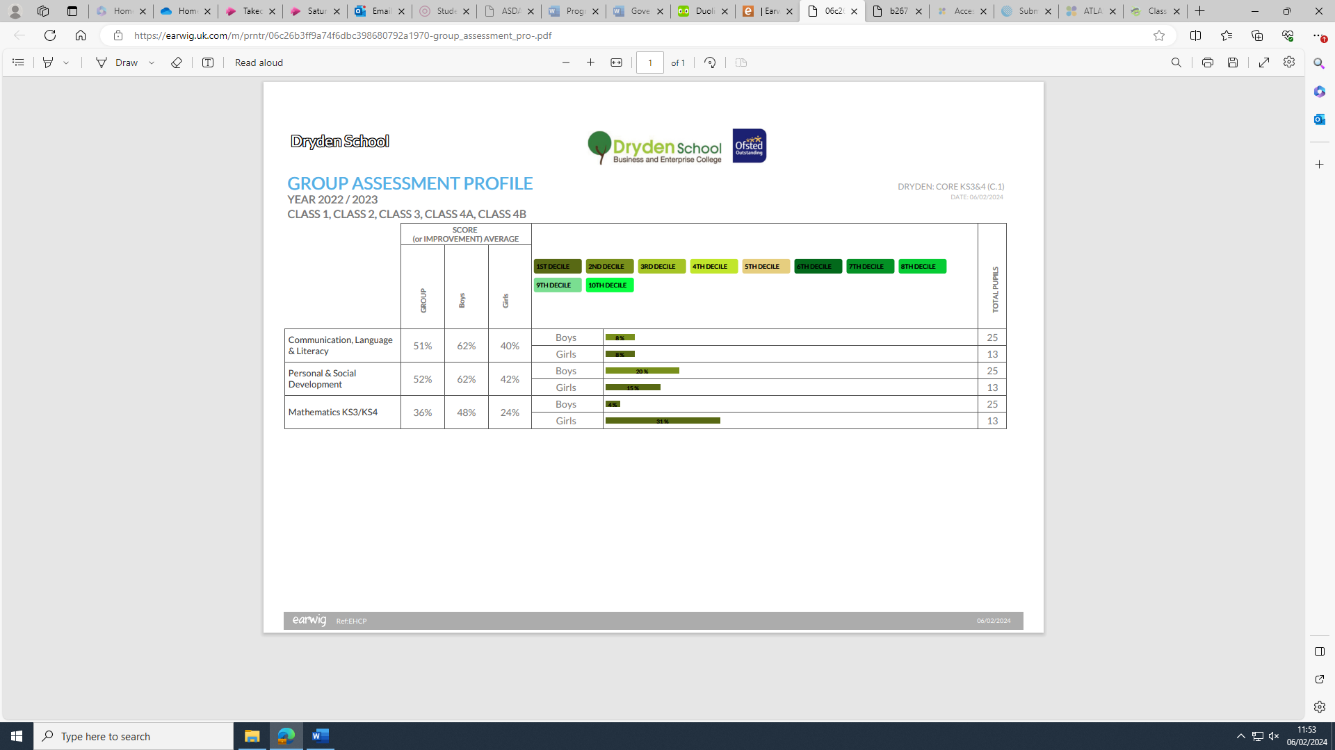The above table shows analysis of the same data but compares the results as a whole with the subgroup of Looked After Pupils. We see the same trend in the data with PSD showing higher results than Maths and English.  The LAC pupils do slightly over perform as a subgroup but with only 5 pupils in this group it only takes one pupil with higher ability to skew the results.

The above table shows the spread of working levels across all pupils assessed with the Core Framework assessed by gender. It is difficult to attribute statistical significance to a set of data where there are only 13 girls, however we can still observe trends. Boys are seen to outperform girls across the curriculum. However, within the cohort of girls we see, unusually, 4 girls in the Autism Class working at a low level. We also have a number of high ability boys in Class 2 and Class 4a which will explain the data.

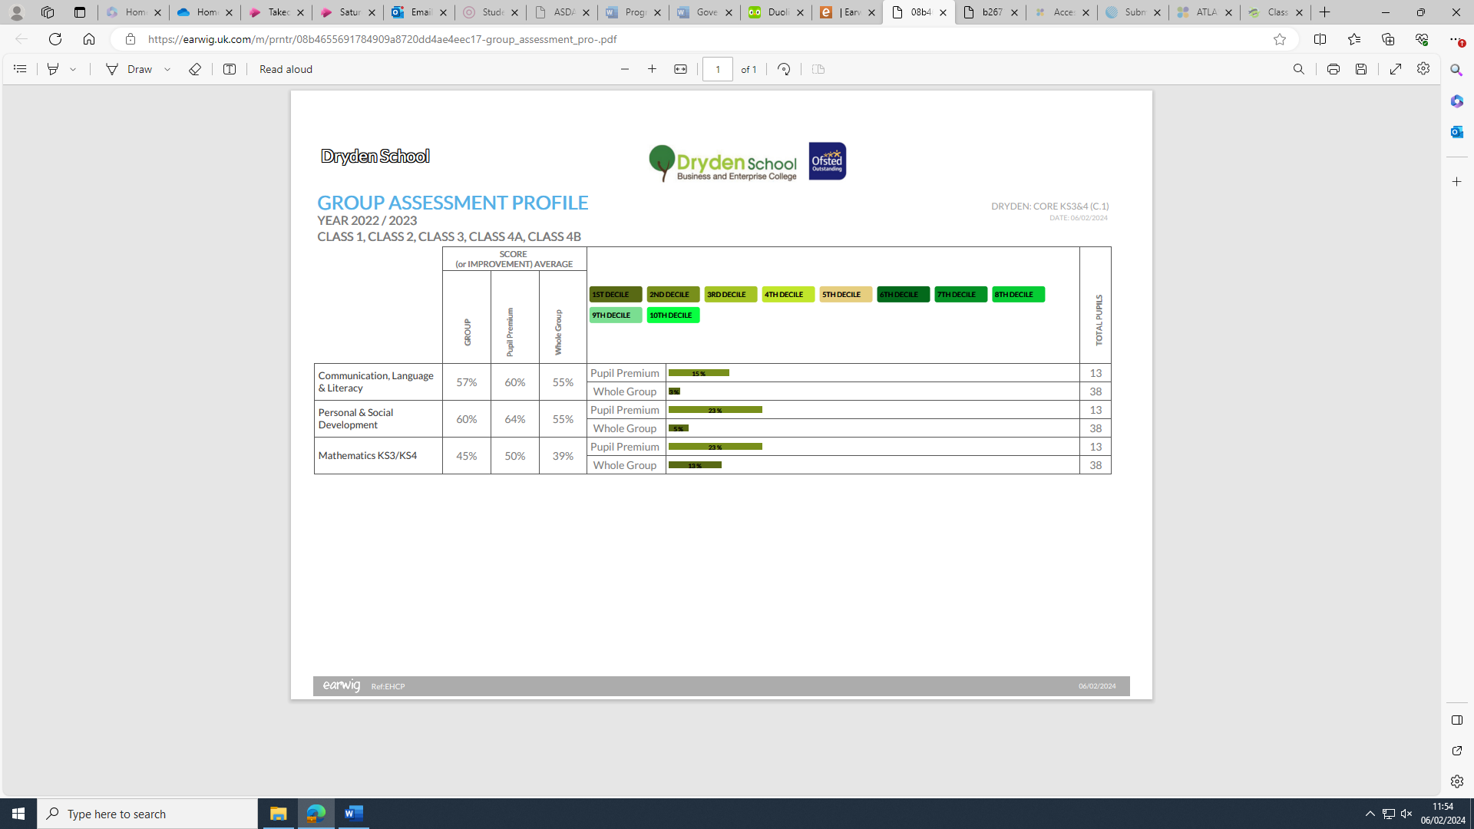

The above chart shows there is no statistically significant variation between those on pupil premium and the whole group.

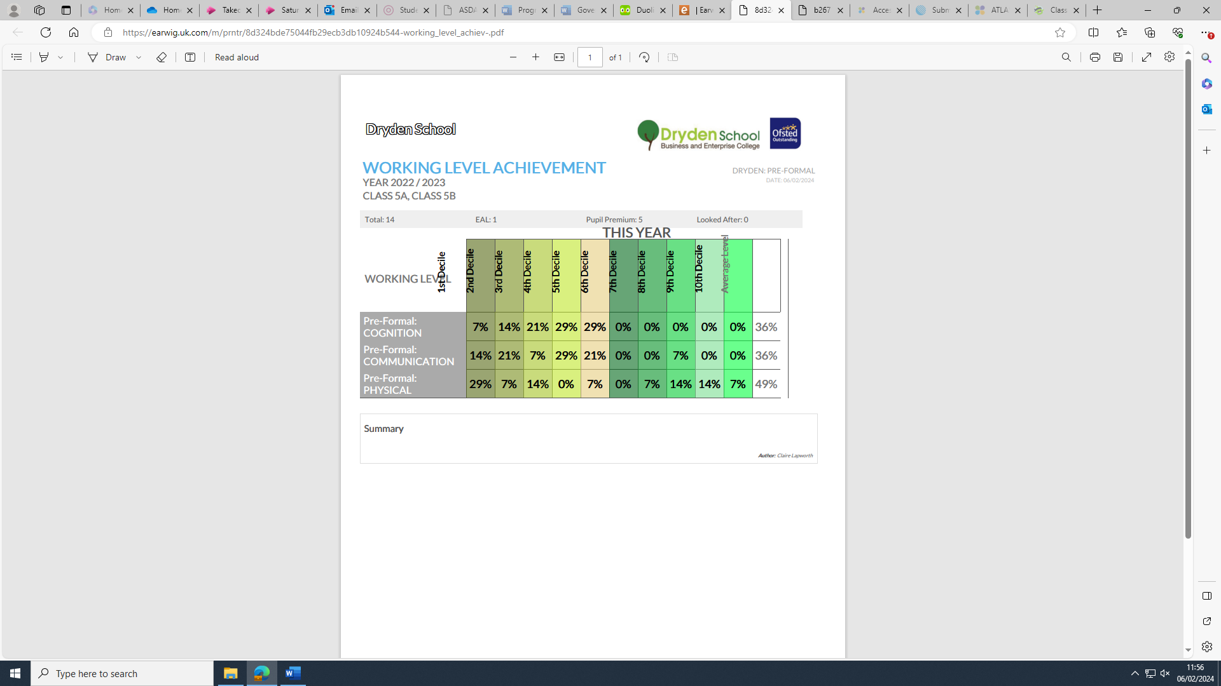The above grid shows the spread of working levels across those pupils in Class 5 who are accessing the preformal curriculum. These results are in line with what we would expect for that group. We now have an increased focus on engagement the engagement model with communication being a key part of this. We do see an increase in the overall physical score which is as a result of the new Year 7 intake. These pupils are following a pre formal pathway and are being assessed using the engagement model but all are fully ambulant.

**Post 16**

As an outcome at the end of KS4, each pupil will aim to gain accreditation in ASDAN: Towards Independence, where they will study modules leading to accreditation in preparation for further ASDAN accreditation in the 6th form, Pupil Progress or Employability. The following data demonstrates the pass rate with our pupils.

|  |  |  |
| --- | --- | --- |
| ***Post16 Progress***  ***Courses   2022-2023*** | **No Students** | **%**  **Pass** |
| **ASDAN**  **Towards Independence**  Independent Living: Introduction    **Pupil Progress**    **Employability** | **Cohort = 4**      Cohort = 3    Cohort = 4 | 100% |

**Destinations**

We aim to support students towards adult pathways and start looking at potential pathways through our annual review process as early as Year 9. Great care is taken to ensure students can optimise learning opportunities through the curriculum looking to the broader picture beyond school. Destinations include college, internships, employment and social care services. The following data shows the destination of school leavers for the past 3 years.

|  |  |  |  |  |  |  |
| --- | --- | --- | --- | --- | --- | --- |
| ***Destination of school leavers*** | ***2021*** | | ***2022*** | | ***2023*** | |
| ***Cohort*** | ***11*** | | ***6*** | | ***7*** | |
| ***School Leavers*** | ***No students*** | ***%*** | ***No students*** | ***%*** | ***No students*** | ***%*** |
| ***Independent Education Provider*** | *0* | *0* | *3* | *50%* | *3* | *43%* |
| ***Gateshead College*** | *1* | *9%* | *0* | *0* | *3* | *43%* |
| ***Learning Skills*** | *7* | *63%* | *1* | *17%* | *0* | *0* |
| ***Employment*** | 0 | 0 | 0 | 0 | 0 | 0 |
| ***Internship*** | 0 | 0 | *1* | *17%* | *0* | *0* |
| ***Other*** | *1* | *9%* | *0* | *0* | *1* | *14%* |
| ***Did not stay at school for P16 education*** | *0* | 0 | 0 | 0 | 0 | 0 |
| ***Social Care/Adult Services*** | *2* | *29%* | *1* | *17%* | *0* | *0* |