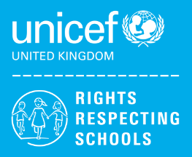 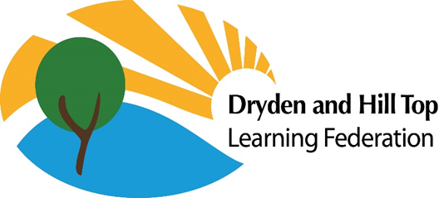 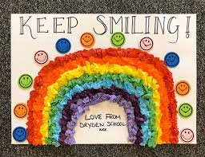

**RIGHTS RESPECTING SCHOOL POLICY STATEMENT**

The United Nations Convention on the Rights of the Child (UNCRC) contains 54 articles and was ratified by the UK in 1991. The pupils and staff of Dryden School Gateshead have identified the following articles from the UNCRC as being of relevance in formulating this policy:

*Article 1* Everyone under the age of 18 has all the rights in the Convention from birth.

*Article 2* The Convention applies to every child without discrimination, whatever their ethnicity, sex, religion, language, abilities or any other status, whatever they think or say, whatever their family background.

*Article 5* Governments must respect the rights and responsibilities of parents and carers to provide guidance and direction to their child as they grow up, so that they fully enjoy their rights. *This must be done in a way that recognises the child’s increasing capacity to make their own choices.*

*Article 12* Every child has the right to express their views, feelings and wishes in all matters affecting them, and to have their views considered and taken seriously.

*Article 15* Children have the right to meet with others and join groups.

*Article 23* Children with a disability have the right to live a full and decent life with dignity and, as far as possible, independence and to play an active part in the community. Governments must do all they can to support disabled children and their families.

*Article 29* Education must develop children’s talents to the full.

*Article 31* Children have the rights to relax and play.

*Article 42* Governments must actively work to make sure children and adults know about the Convention.

Purpose: To provide a sustainable rights respecting environment which ensures:

· All children feel safe at school

· All children feel valued as individuals

· All children have high levels of well-being and emotional resilience

· All children engage both with their own learning and with the school community

· All children are active global citizens

All resources and texts are available and accessible to all staff and students, including through symbols.

**Whole School Approach**

Dryden School will use a whole school approach to teach the students about their rights.

The UNCRC states that Rights are universal and cannot be taken away. The children are given whole school opportunities to learn about their rights, and about situations where children in other places may not always have access to their rights.

At weekly assemblies, Children’s Rights are introduced and explored through current affairs topics. This will, if appropriate tie in with other events within the school community.

The school will have Rights Ambassadors within the pupil population, as part of school council. They will help support their peers in learning about Rights and organise events to highlight where Rights are needed and exercised in the wider community, however the main responsibility for ensuring that all children enjoy their rights lies with adults, as Duty Bearers.

The children are taught that rights are Universal, Inherent, Inalienable, Unconditional and Indivisible.

All pupils are involved in the creation of a school charter showing the articles identified by the children as key, this is discussed weekly in classes through a PowerPoint presentation. Classes discuss the duties of adults and how they as children will respect the rights of everyone. This charter will then be signed by staff and pupils to show their agreement with it.

Children are given opportunities to develop their knowledge and awareness of how they can have a positive impact on the world, now and in the future through the delivery of PSHE, RE and special events.