

Charging and Lettings Policy

Responsibility for Policy: Angela Young

Date policy written/rewritten:

Date policy ratified by governors: 27th June 2007

Dates policy reviewed: 17th November 2008 2nd December 2010

17th November 2011

22nd November 2012

30th January 2014

24th February 2015

1st February 2016

23rd Jan 2017

29th Jan 2018

29th Jan 2019

29th Jan 2020

10th Feb 2021

9th Feb 2022

Summer 2023

Autumn 2024

**Introduction**

This policy is adopted by the governors and is in line with that of Gateshead LA. The Governing Body should determine annually a scale of fees and charges for the supply of goods or services by the school, including fees for lettings. Fees must be set at a level to at least cover the cost of earning those fees.

The Headteacher is responsible to the Governing Body for accounting for all income due from charging and lettings.

**Curriculum Activities:**

This establishes that activities offered wholly or mainly during normal teaching time should be available to all pupils regardless of their parent’s ability or willingness to meet the costs. It confirms the right of the school to invite voluntary contributions for the benefit of the school or in support of any activity organised by the school whether during or outside of school hours.

For education during school hours no charge is made for equipment, materials or books. However the school may invite parents to contribute towards the cost of materials for certain practical activities (e.g. class drinks/biscuits; cookery).

**Use of Premises - Lettings Charge:**

School premises are sometimes used for an After School Club for pupils, and during the evening for governors meetings, Open evenings for parents and occasional events organised by the Friends of Dryden School and Hill Top PTA. In addition there are sometimes evening and week-end bookings and the school has previously been used during the summer holiday period for the Active Kidz Scheme. School physiotherapists may use the hydrotherapy pool for individual pupils during some holiday periods.

The charging policy adopted by the school Governing Body is designed to reflect the following costs:- caretaking, cleaning, heating, lighting, wear & tear and a small amount of profit (when used for other than school-related functions). Any profit made from lettings is used to enhance and extend activities for students at the school, and particularly to enhance extended services activities e.g. After School Clubs, which helps to reduce costs to parents. The fixing of annual Letting Charges is reviewed and agreed annually by the Finance & Staffing committee.

**Income from lettings**

The responsibilities for agreeing the terms and conditions of lettings and charges due are clearly defined by the Governing Body. Any income coming into school from lettings is held in a separate cost centre and is used to offset against: caretaking, cleaning, heating, lighting, wear & tear and After School Clubs costs.

A record of lettings is maintained.

A letter is issued to the hirer and a copy retained on file.

If lettings fees are not received in advance, they should be promptly billed to the organisation. The school will liaise closely with Exchequer Services, Learning and Children to monitor payment of debtors’ accounts and to ensure they are paid without undue delay as part of the Debtors buy-back service.

This policy will be reviewed and updated annually.

# Cross Referenced to:

# Gateshead Council Local Management of schools manual of financial procedures(Section 4-Income

1. Hydrotherapy Pool Policy

**Appendices:**

1. Gateshead Council lettings and charges rates – current
2. Dryden and Hill Top Federation Hiring Conditions

**Appendix 1**

# **DRYDEN AND HILL TOP LEARNING FEDERATION : LOCAL HIRING CONDITIONS**

The School Governing Body issues these 'Local Hiring Conditions' in line with directions and advice given by the Local Authority and the Health and Safety Executive. The school premises will only be made available for hire by members of the community when they are not required for school use.

Hirers must strictly adhere to the SMOKE FREE POLICY which applies to the entire school premises (both internal and external)

## Health and Safety Requirements

### Access to the telephone

Hirers must provide their own mobile telephone for use in an emergency.

The school must be provided with a telephone number and address where the hirer can be contacted in case there is a breakdown in the telephone system, so that if it is necessary the letting of the premises can be cancelled.

**First Aid Boxes**

First aid boxes are available for use if necessary, and can be located throughout the school building. These will be highlighted to the hirer prior to the first letting commencing.

**Access to Fire Fighting Equipment**

Fire warning: Continuous sounding bell.

Fire alarm activators: Red box with glass insert (wall mounted).

Fire equipment: Fire extinguishers & fire blankets.

Fire Equipment will be highlighted to the hirer prior to the first letting commencing. Most rooms have emergency fire doors attached. It is vital that the hirer checks out the positions of all fire exits for him/herself, so that in the case of an emergency a route of escape from the building has already been considered.

**FIRE PROCEDURE:**

A copy of the school Fire Procedures is provided to the hirer, and further copies are located throughout the school building). The hirer should undertake a fire risk assessment prior to using the premises (the school’s fire risk assessment will be made available to the hirer, upon request)

On discovery of fire:-

**\***PUSH/BREAK GLASS IN NEAREST FIRE ALARM ACTIVATOR **\***PRIORITY IS TO CLEAR BUILDING NOT TO FIGHT THE FIRE **\***LEAVE BY NEAREST FIRE EXIT

**\***GO TO ASSEMBLY POINT IN MAIN YARD – Dryden

*GO TO ASSEMBLY POINT AT the Multi Use Games Area – HILL TOP

**Equipment and Materials**

Any equipment or materials needed by the hirer must be detailed specifically.

**Nature of activity**

The hirer is asked to state the specific nature of the activity to be undertaken in order that the school can be sure the premises are suitable for the purpose. If the nature of the activity is inany way hazardous (e.g.sporting activities), the hirer will be asked to produce evidence of up to date qualifications pertinent to the proposed activity.

**User Number Limits**

It isimportant that the hirer states the number of participants for the activity. Depending on the activity and the age of participants, it may be necessary to limit the numbers taking part in any given session.

**Safeguarding**

For other services or activities which are provided separately by another body, using the school premises, the Governing Body will seek assurance that the body concerned has appropriate policies and procedures in place in regard to Safeguarding children and child protection.

**Public Liability Insurance**

For other services or activities which are provided separately by another body, using the school premises, the Governing Body will seek assurance that the body concerned has appropriate Public Liability Insurance.

**Appendix 2**

Lettings

# **Method of Calculation**

The lettings payments paid to Site Managers are calculated based on a number of different variables. The main being how many rooms were used as part of the letting, and how big the rooms are.

Generally a classroom is classed as 1 room (most classrooms are the same size), with larger rooms such as School Halls, Gyms, and Sports Halls being the equivalent of 2, 3, or 4 rooms.

These values are based on measurements taken by the Operational Services section based in the Civic Centre.

The Site Manager is not paid based on the number of hours worked, but on the number of hours deemed necessary to open and close the number of rooms used (or equivalent number of rooms).

The following table shows how the calculations are made, and can be used as a guide to work out the cost of a letting.

## Rooms Mon-Fri Saturday Sunday

1-5 2.25 3.38 4.5

6-12 2.50 3.75 5.00

13-18 2.75 4.13 5.50

Over 18 3.00 4.50 6.00

The equivalent sizes of the rooms vary by school, however for example:

If a letting takes place on a Monday evening between 6.00pm, and 9.00pm, the Hall (worth 2 rooms) and toilets (Male and Female, 1 room each) are used then the total number of rooms used is 4.

From the above table it can be seen that 4 rooms, used between Monday and Friday pays **2.25hrs.** Conversely, if the letting had taken place on a Saturday or a Sunday then the letting would be worth **3.38hrs**, and **4.5hrs** respectively unless a flat rate is used for weekend working.

These hours are paid at the employee’s 39hr rate, which is their normal hourly rate less 5.1%

If the Site Manager claims for “all rooms” or “whole school”, then the minimum payment will be made.

# **Bands**

When lettings are claimed over the weekend, then the banding system comes into effect. There are 3 bands, which are:

Band 1 9.00am – 1.00pm

Band 2 1.00pm – 6.00pm

Band 3 6.00pm – 10.30pm

If a letting encompasses more than one band, then the employee is entitled to be paid for the letting for each band it spans.

For example, if 6 rooms are used on a Sunday, between 10.00am, and 7.00pm, then the payment is made as follows

Band 1 = 5.00hrs

Band 2 = 5.00hrs

Band 3 = 5.00hrs

## Total 15.00hrs

If one letting closely follows another, and some or all of the same rooms are used (see example below), then the employee is only paid once for the rooms.

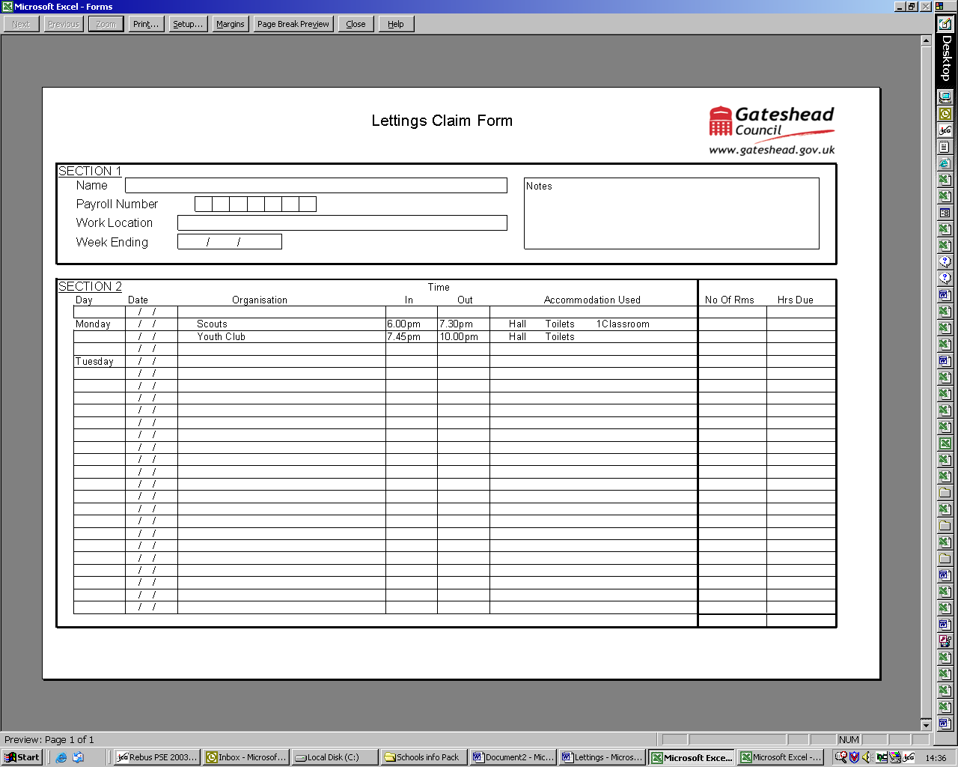

# **Cleaning after Lettings**

Cleaning should be claimed on the reverse of the Lettings claim form, *only* if the Site Manager has performed active cleaning duties *after* the letting.

The payments are made at time and a half, or double time, depending on which rate applies at the time the work is carried out, and for the number of hours worked (as per normal overtime payments.

|  |  |  |  |  |  |
| --- | --- | --- | --- | --- | --- |
|  |  |  |  |  |  |
| **GATESHEAD METROPOLITAN BOROUGH COUNCIL** | | | | | |
|  |  |  |  |  |  |
| **LEARNING & CHILDREN** | | | | | |
|  |  |  |  |  |  |
| **LETTINGS / CLEANING RATES FROM 1st Jan 2018** | | | | | |
|  |  |  |  |  |  |
|  |  |  |  |  |  |
|  |  |  |  |  |  |
|  |  |  |  |  |  |
|  |  |  |  |  |  |
|  |  |  |  |  |  |
|  |  |  |  |  |  |
| **1. LETTINGS (Caretaker/Site Manager)** |  |  |  |  |  |
| AREA HIRED | WEEK DAY |  | SATURDAY |  | SUNDAY |
| (Payments are per Letting) | PAYMENT (£) |  | PAYMENT (£) |  | PAYMENT (£) |
|  |  |  |  |  |  |
| **UP TO 5 ROOMS** | **19.41** |  | **29.17** |  | **38.83** |  |
| 6 - 12 ROOMS | 21.57 |  | 32.36 |  | 43.14 |  |
| 13 - 18 ROOMS | 23.73 |  | 35.64 |  | 47.46 |  |
| OVER 18 ROOMS | 25.89 |  | 38.83 |  | 51.77 |  |
|  |  |  |  |  |  |
| **2. CLEANING AFTER LETTINGS(Caretaker/Site Manager)** | |  |  |  |  |
|  |  |  |  |  |  |
|  |  |  |  |  |  |
| The payment for the cleaning after lettings is based on the hours actually worked at the 39 hour rate therefore  Mon – Sat @time and a half  Sunday @double time. | | | | | |
|  | | | |  |  |
|  |  |  |  |  |  |
| **3. CLEANING AFTER LETTINGS (CONTRACT CLEANING)** | | |  |  |  |
| RATES AVAILABLE FROM CONTRACTOR | |  |  |  |  |
|  |  |  |  |  |  |
| 4. **ENERGY COSTS** |  |  |  |  |  |
| THE AVERAGE COST PER 100 SQUARE METRES PER HOUR:- | | |  |  |  |
|  |  |  |  |  |  |
| For all Primary Schools is | 83.08 |  |  |  |  |
| For all Secondary Schools is | 83.08 |  |  |  |  |

Name ……………………. Company ……………

Signed …………………. Period of letting . . . . . . .